**Devices and Circuits Laboratory**

**Experiment-6**

**Basic Operational Amplifier Circuits**

Group : 1

Aditya Kalyani - 200020003

Tanish H Talapaneni - 200020050

**Objectives:**

1. To build inverting, non-inverting amplifier, differentiator and integrator using Op-Amps

**Inverting Amplifier**

1. Output and Input Waveform

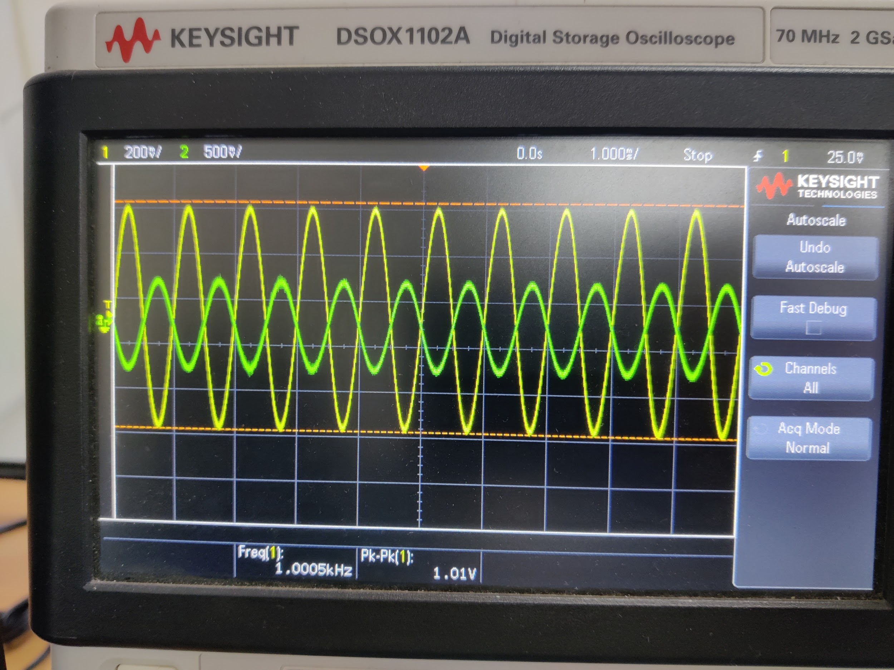

1. Output and Input Waveform for increased amplitude

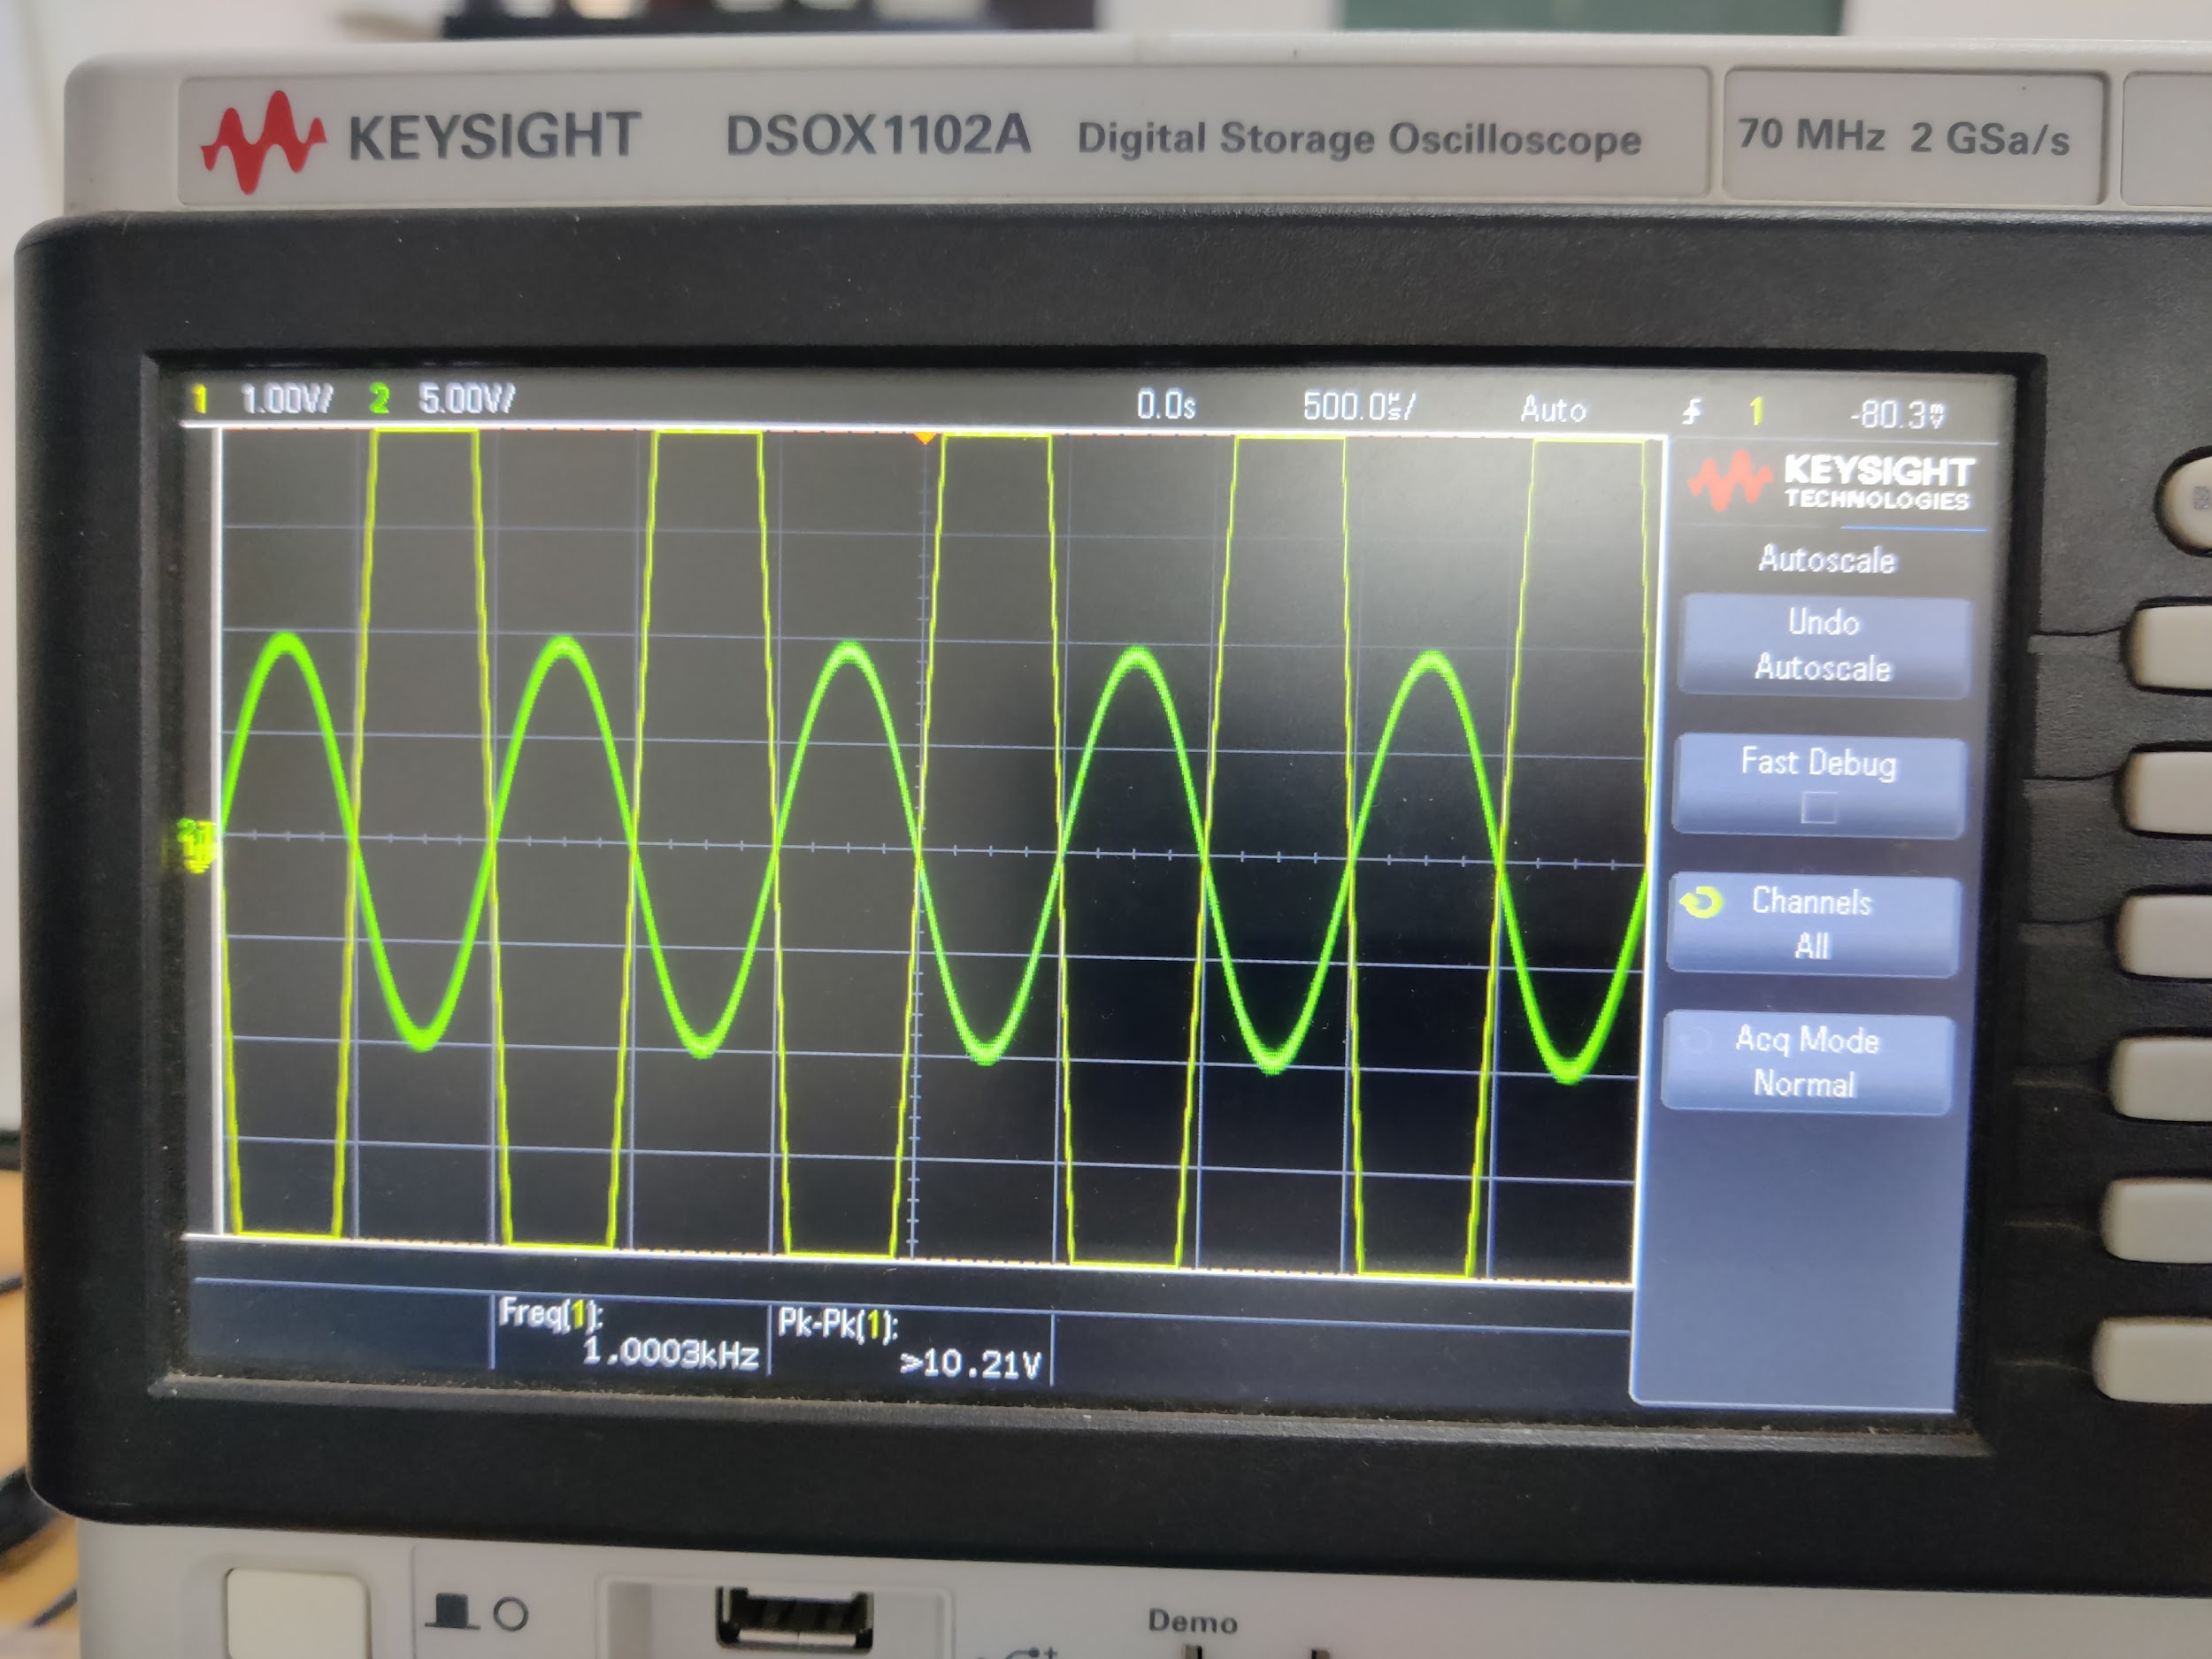

**Observation**: The.output waveform gets tripped because the output voltage exceeds the parameters allowed for the given op-amp.

3.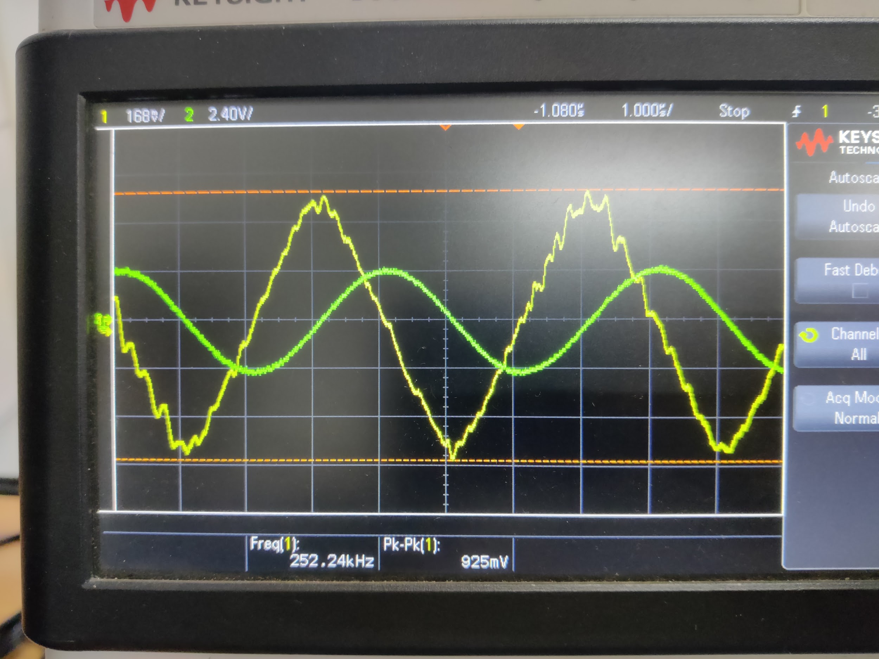

Frequency = 175kHz

**Slew Rate**= dV/dt = 2 $π$**f*v= **0.56 V/ $μs$**

4.

| Frequency(in kHz) | Vin | Vout | Gain(-ve) |
| --- | --- | --- | --- |
| 0.1 | 0.5 | 5.1 | 10.2 |
| 0.5 | 0.5 | 5.2 | 10.4 |
| 1 | 0.5 | 5.2 | 10.4 |
| 2 | 0.5 | 5.2 | 10.4 |
| 10 | 0.5 | 5.1 | 10.2 |
| 50 | 0.5 | 4 | 8 |
| 100 | 0.5 | 3 | 6 |
| 250 | 0.5 | 2 | 4 |
| 500 | 0.5 | 0.7 | 1.4.5 |
| 600 | 0.5 | 0.6 | 1.21 |
| 750 | 0.5 | 0.5 | 15 |
| 900 | 0.5 | 0.4 | 0.8 |
| 1000 | 0.5 | 0.35 | 0.7 |

Gain Vs Frequency: (R=10k)

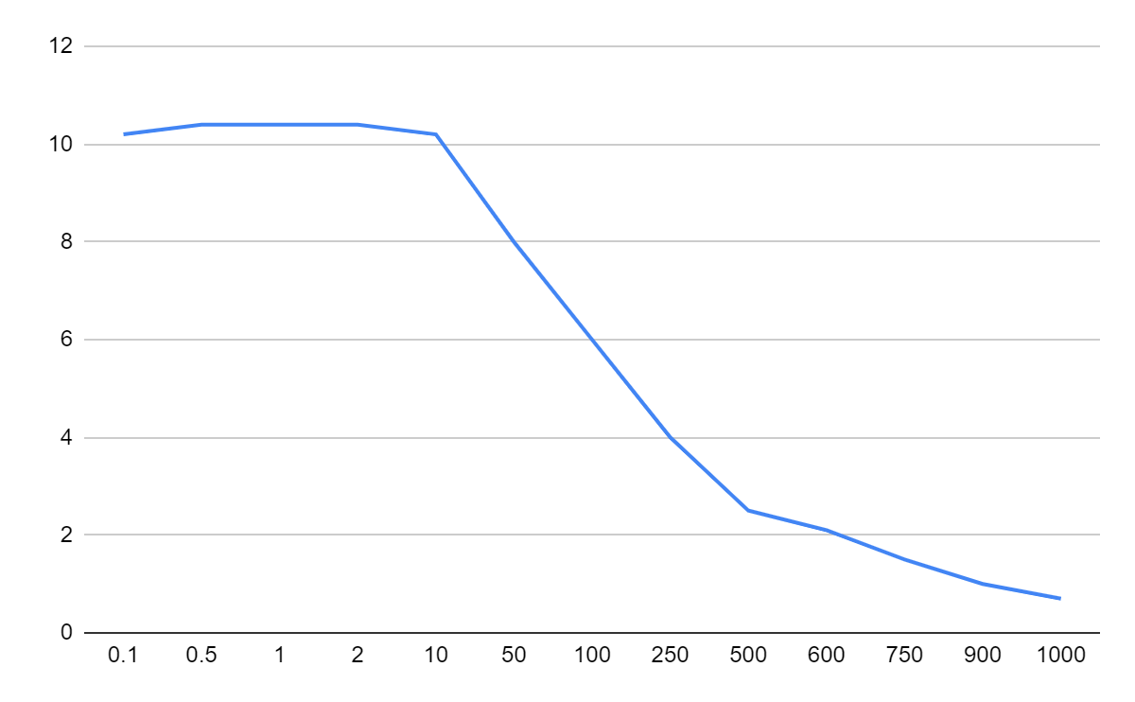

5.

| Frequency(in kHz) | Vin | Vout | Gain(-ve) |
| --- | --- | --- | --- |
| 0.1 | 0.1 | 8.1 | 81 |
| 0.5 | 0.1 | 8.1 | 81 |
| 1 | 0.1 | 8.1 | 81 |
| 2 | 0.1 | 8 | 80 |
| 10 | 0.1 | 7.9 | 79 |
| 50 | 0.1 | 7.8 | 78 |
| 100 | 0.1 | 5.5 | 55 |
| 250 | 0.1 | 3.8 | 38 |
| 500 | 0.1 | 1.4 | 14 |
| 600 | 0.1 | 1.1 | 11 |
| 750 | 0.1 | 1 | 10 |
| 900 | 0.1 | 0.9 | 9 |
| 1000 | 0.1 | 0.8 | 8 |

Gain Vs Frequency: (R = 100k)

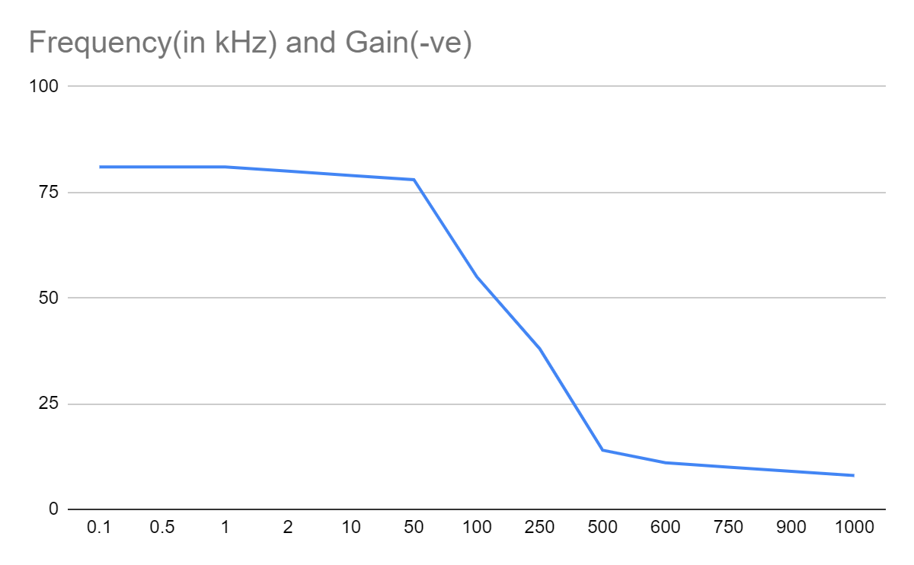

Log-Log plot for graph vs frequency for two different values of resistances

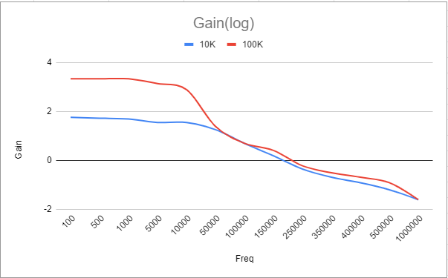

**Non-Inverting Amplifier**

1. Output and Input Waveform

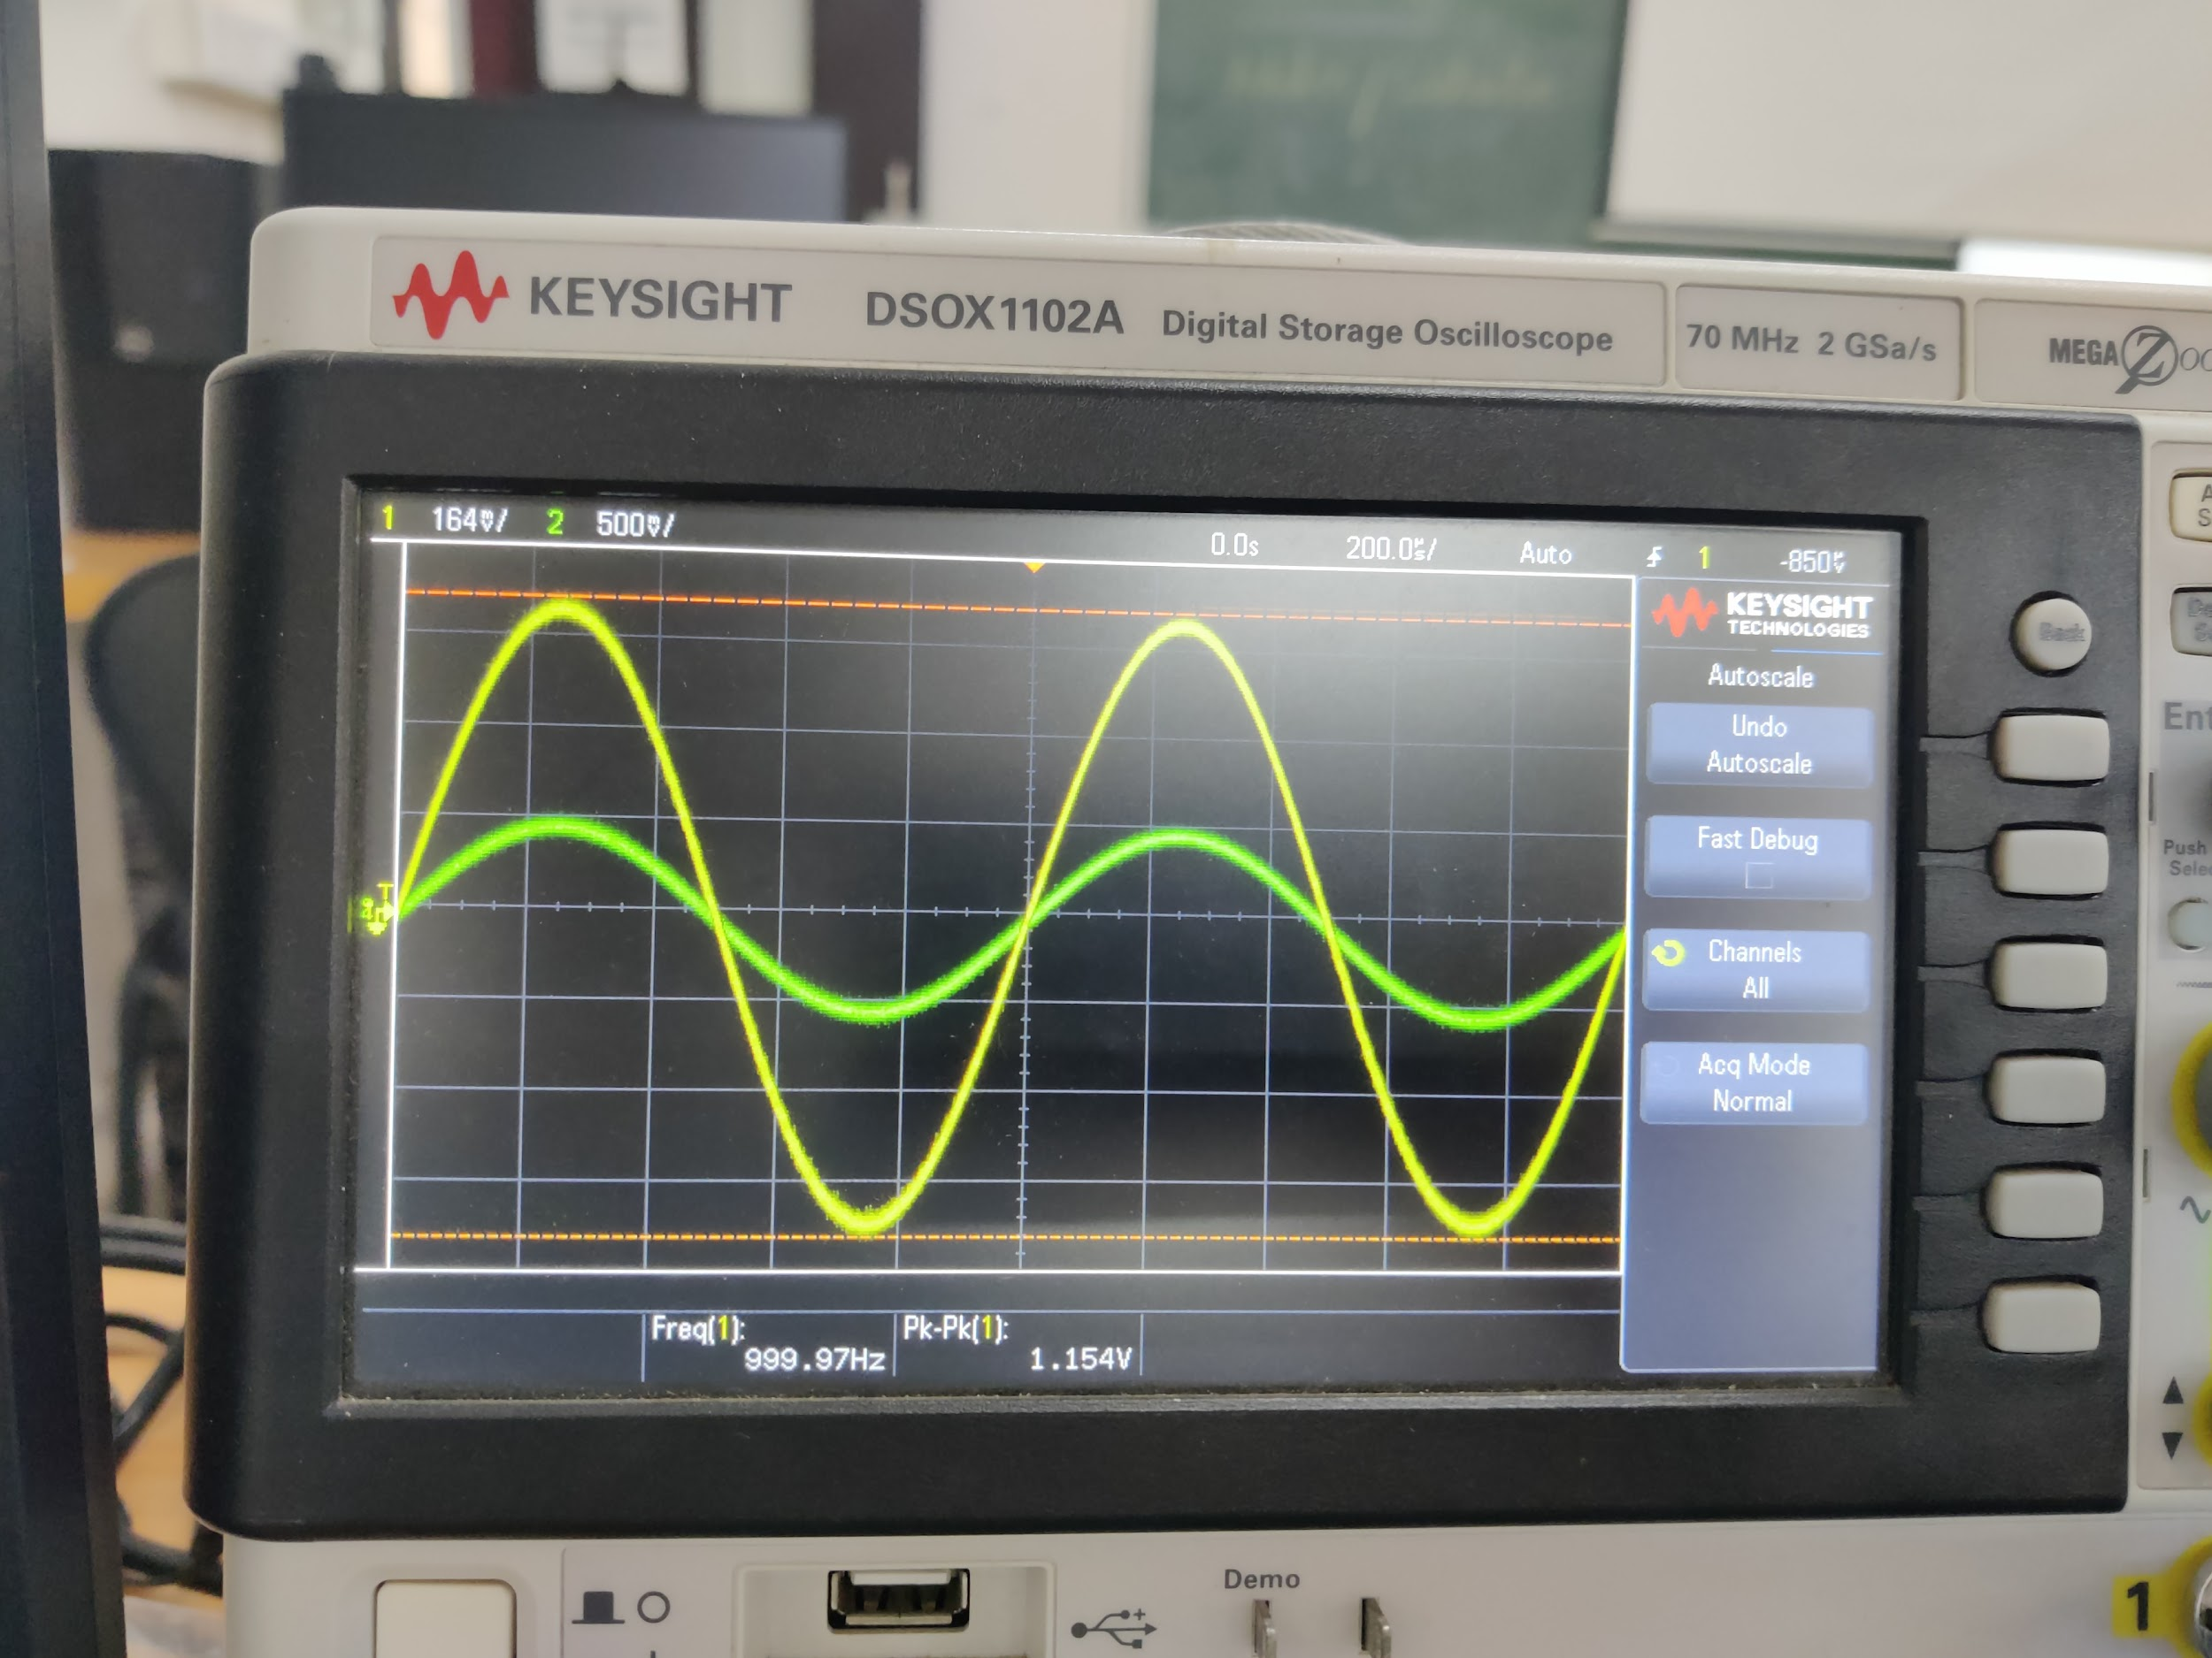

1. Output and Input Waveform for increased amplitude

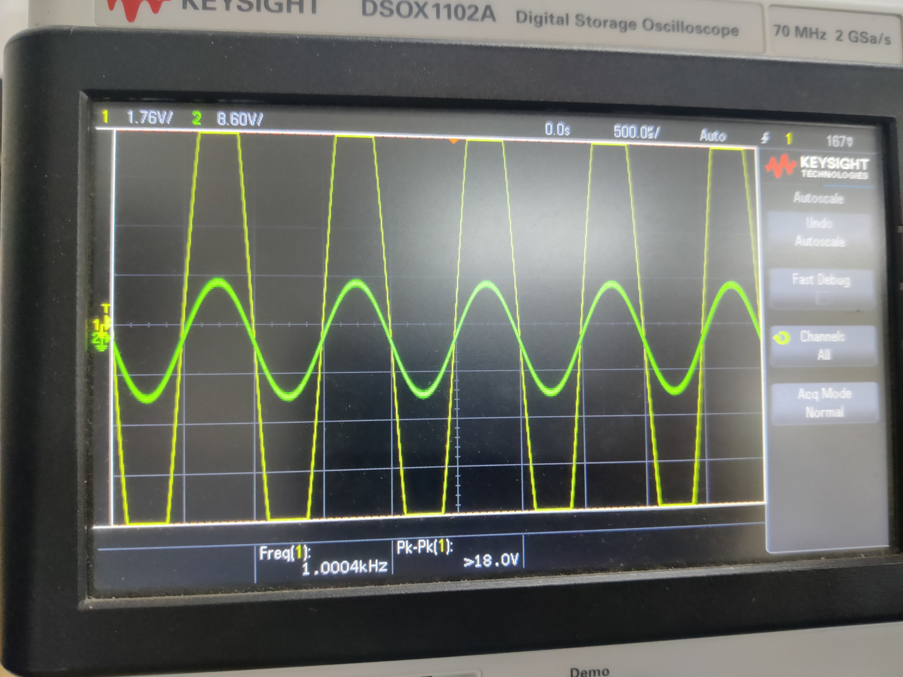

Observation: The.output waveform gets tripped because the output voltage exceeds the parameters allowed for the given op-amp.

3.

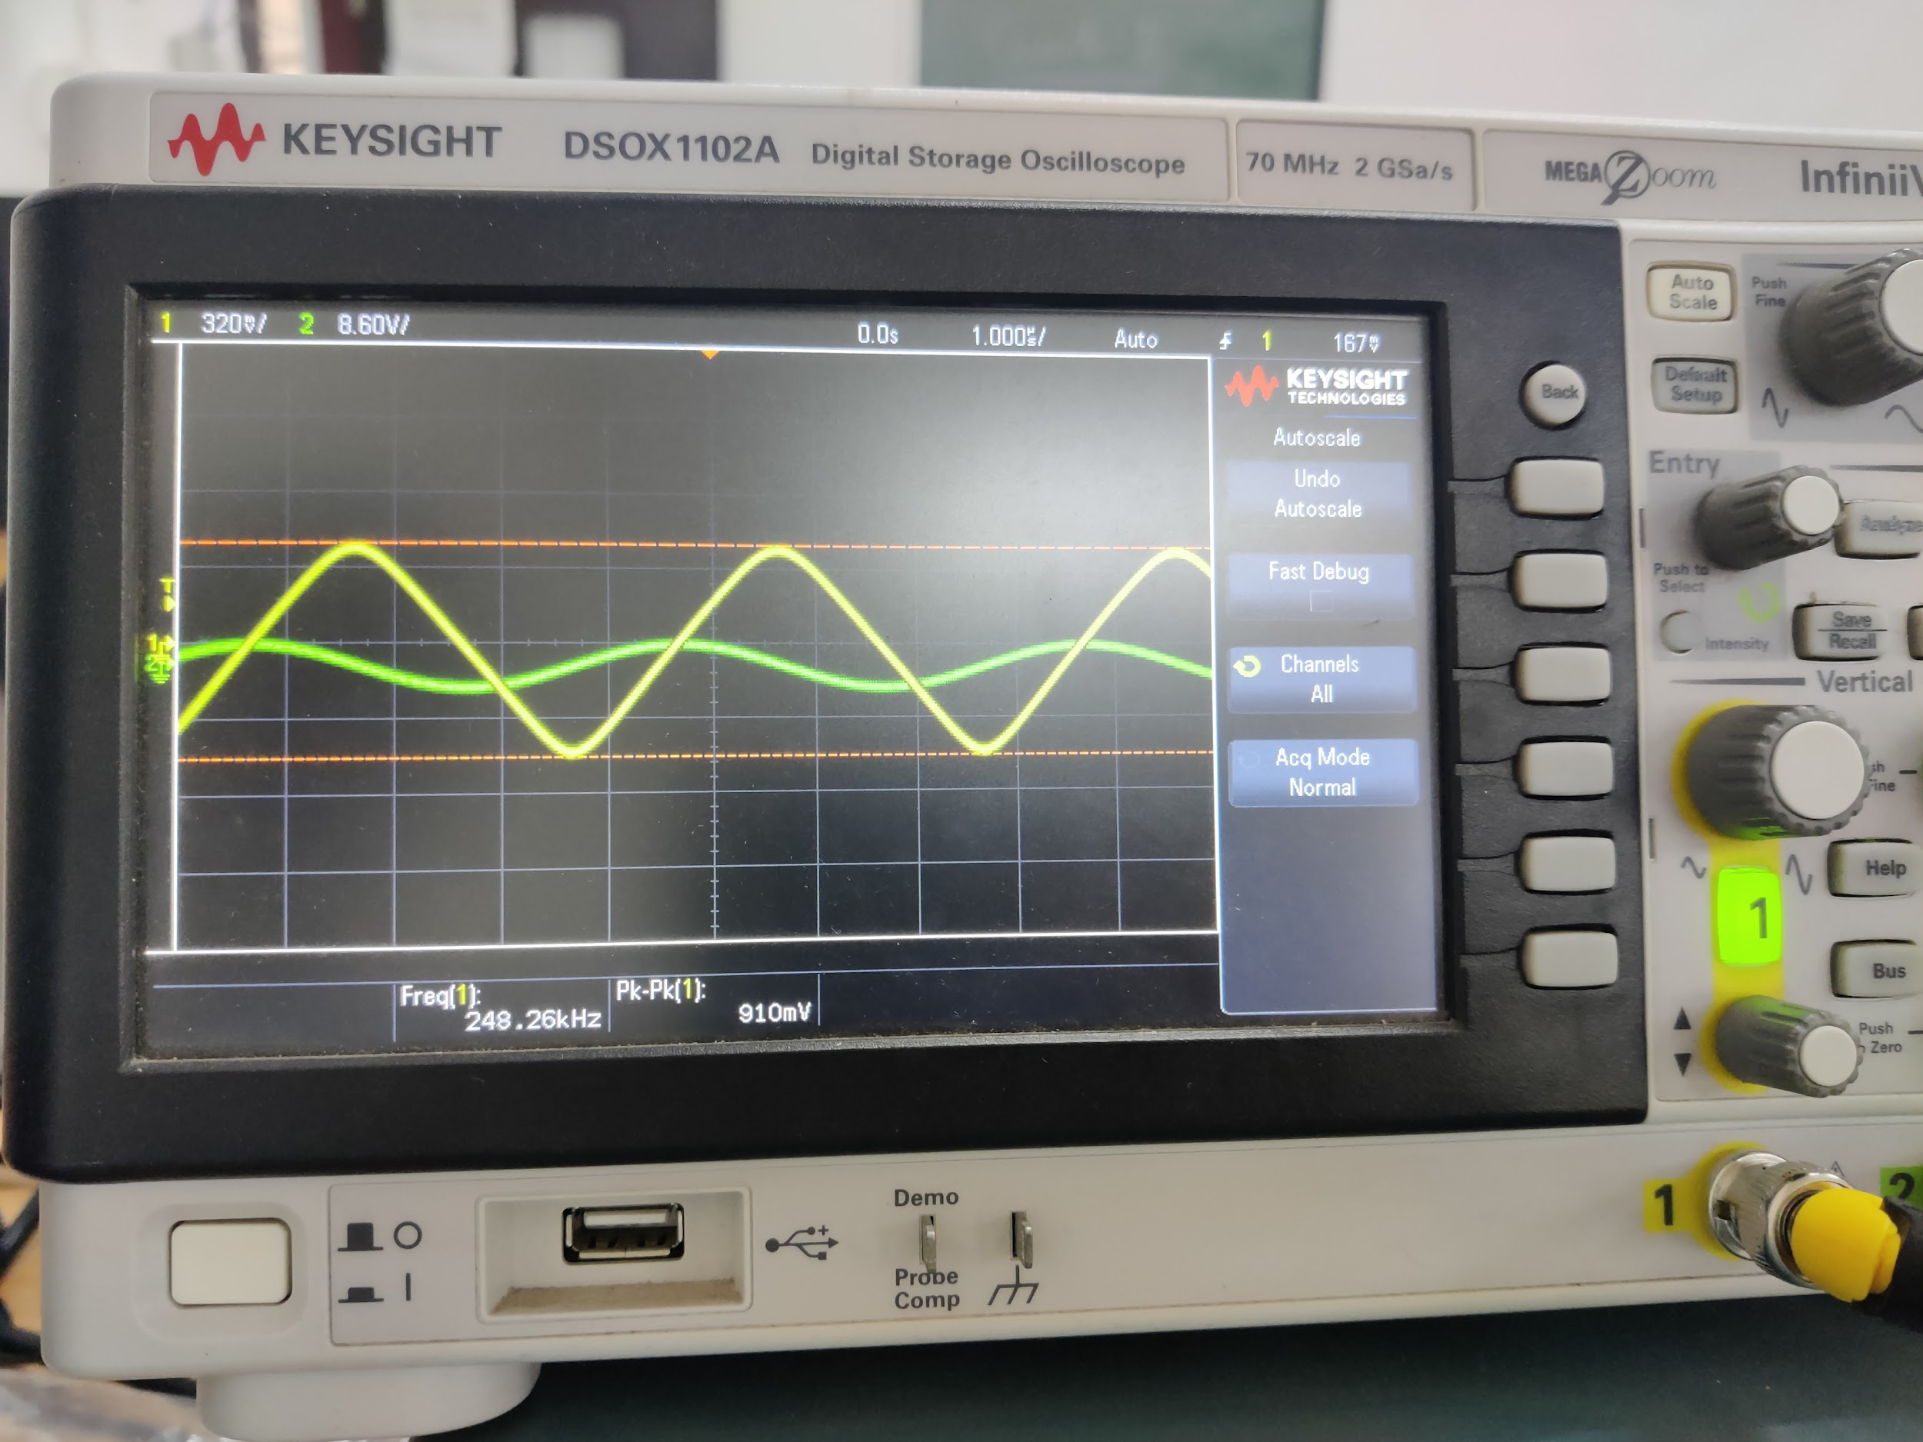

Frequency f = 175k

**Slew Rate**= dV/dt = 2*pi*V/(1/f) = 1.7/175k= **0.56V/ $μ$ s**

4.

| Frequency(in kHz) | Vin | Vout | Gain |
| --- | --- | --- | --- |
| 0.01 | 0.5 | 0.6 | 1.2 |
| 0.02 | 0.5 | 1 | 2 |
| 0.05 | 0.5 | 2 | 4 |
| 0.1 | 0.5 | 3.5 | 7 |
| 0.5 | 0.5 | 5.9 | 11.8 |
| 1 | 0.5 | 5.95 | 11.9 |
| 2 | 0.5 | 5.98 | 11.96 |
| 10 | 0.5 | 5.8 | 11.6 |
| 50 | 0.5 | 4.3 | 8.6 |
| 100 | 0.5 | 2.5 | 5 |
| 250 | 0.5 | 1.5 | 3 |
| 500 | 0.5 | 0.9 | 2.5 |
| 600 | 0.5 | 0.6 | 2.1 |
| 750 | 0.5 | 0.5 | 1.5 |
| 900 | 0.5 | 0.4 | 1 |
| 1000 | 0.5 | 0.35 | 0.7 |

Gain Vs Frequency: (R = 10k)

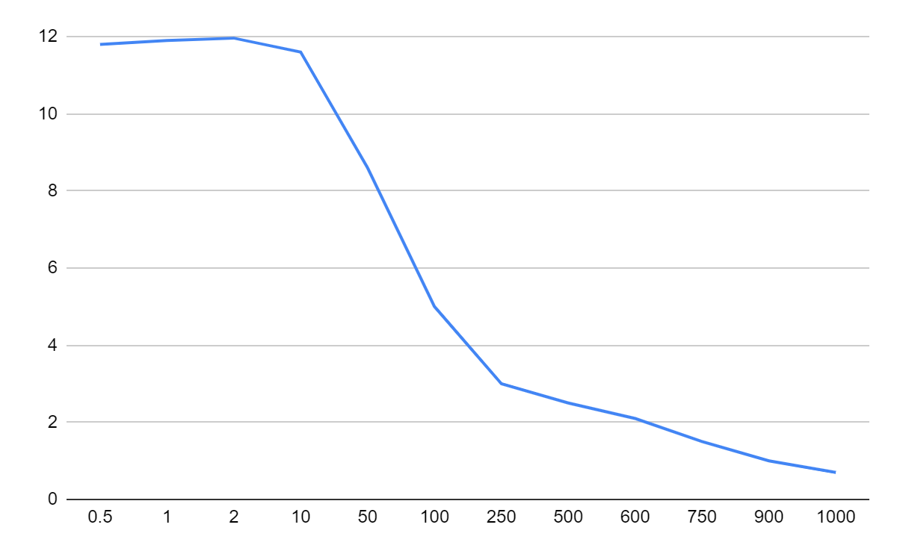

5.

| Frequency(in kHz) | Vin | Vout | Gain |
| --- | --- | --- | --- |
| 0.5 | 0.1 | 8.1 | 81 |
| 1 | 0.1 | 8.15 | 81.5 |
| 2 | 0.1 | 8.2 | 82 |
| 10 | 0.1 | 7.8 | 78 |
| 50 | 0.1 | 7.9 | 79 |
| 100 | 0.1 | 5.2 | 52 |
| 250 | 0.1 | 2.69 | 26.9 |
| 500 | 0.1 | 1.8 | 18 |
| 600 | 0.1 | 1.3 | 13 |
| 750 | 0.1 | 0.9 | 9 |
| 900 | 0.1 | 0.7 | 7 |
| 1000 | 0.1 | 0.65 | 6.5 |

Gain Vs Frequency: (100k)

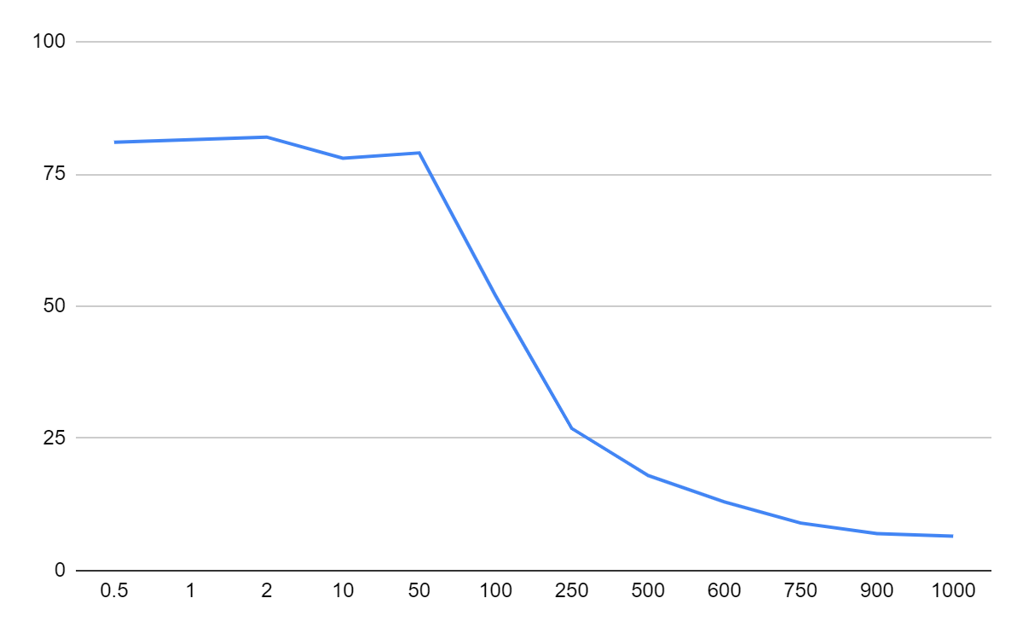

Log-Log plot for different values of resistences



**Integrator**

1.Output and Input Waveform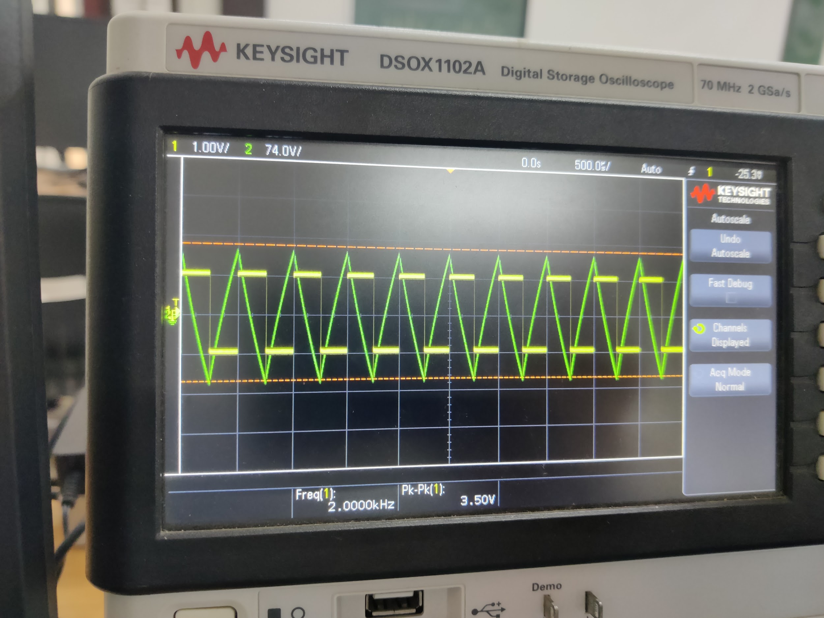

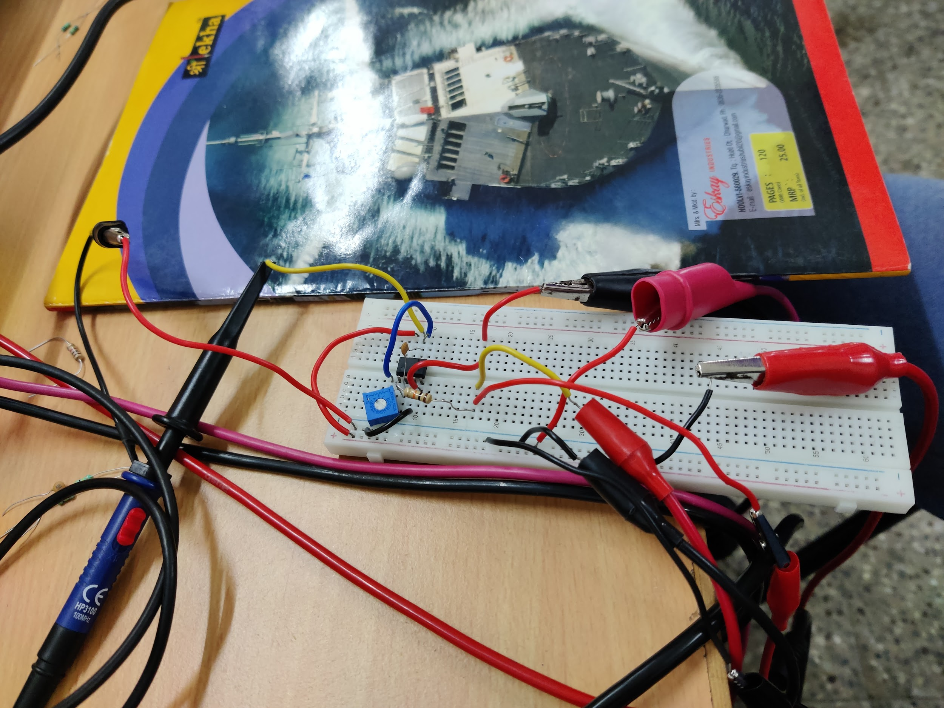

2. For a square wave input, we see a **triangle wave output** in the oscilloscope.

Experimentally, at around the frequency of 20 Hz, The amplitudes of the input and output are the same.

3.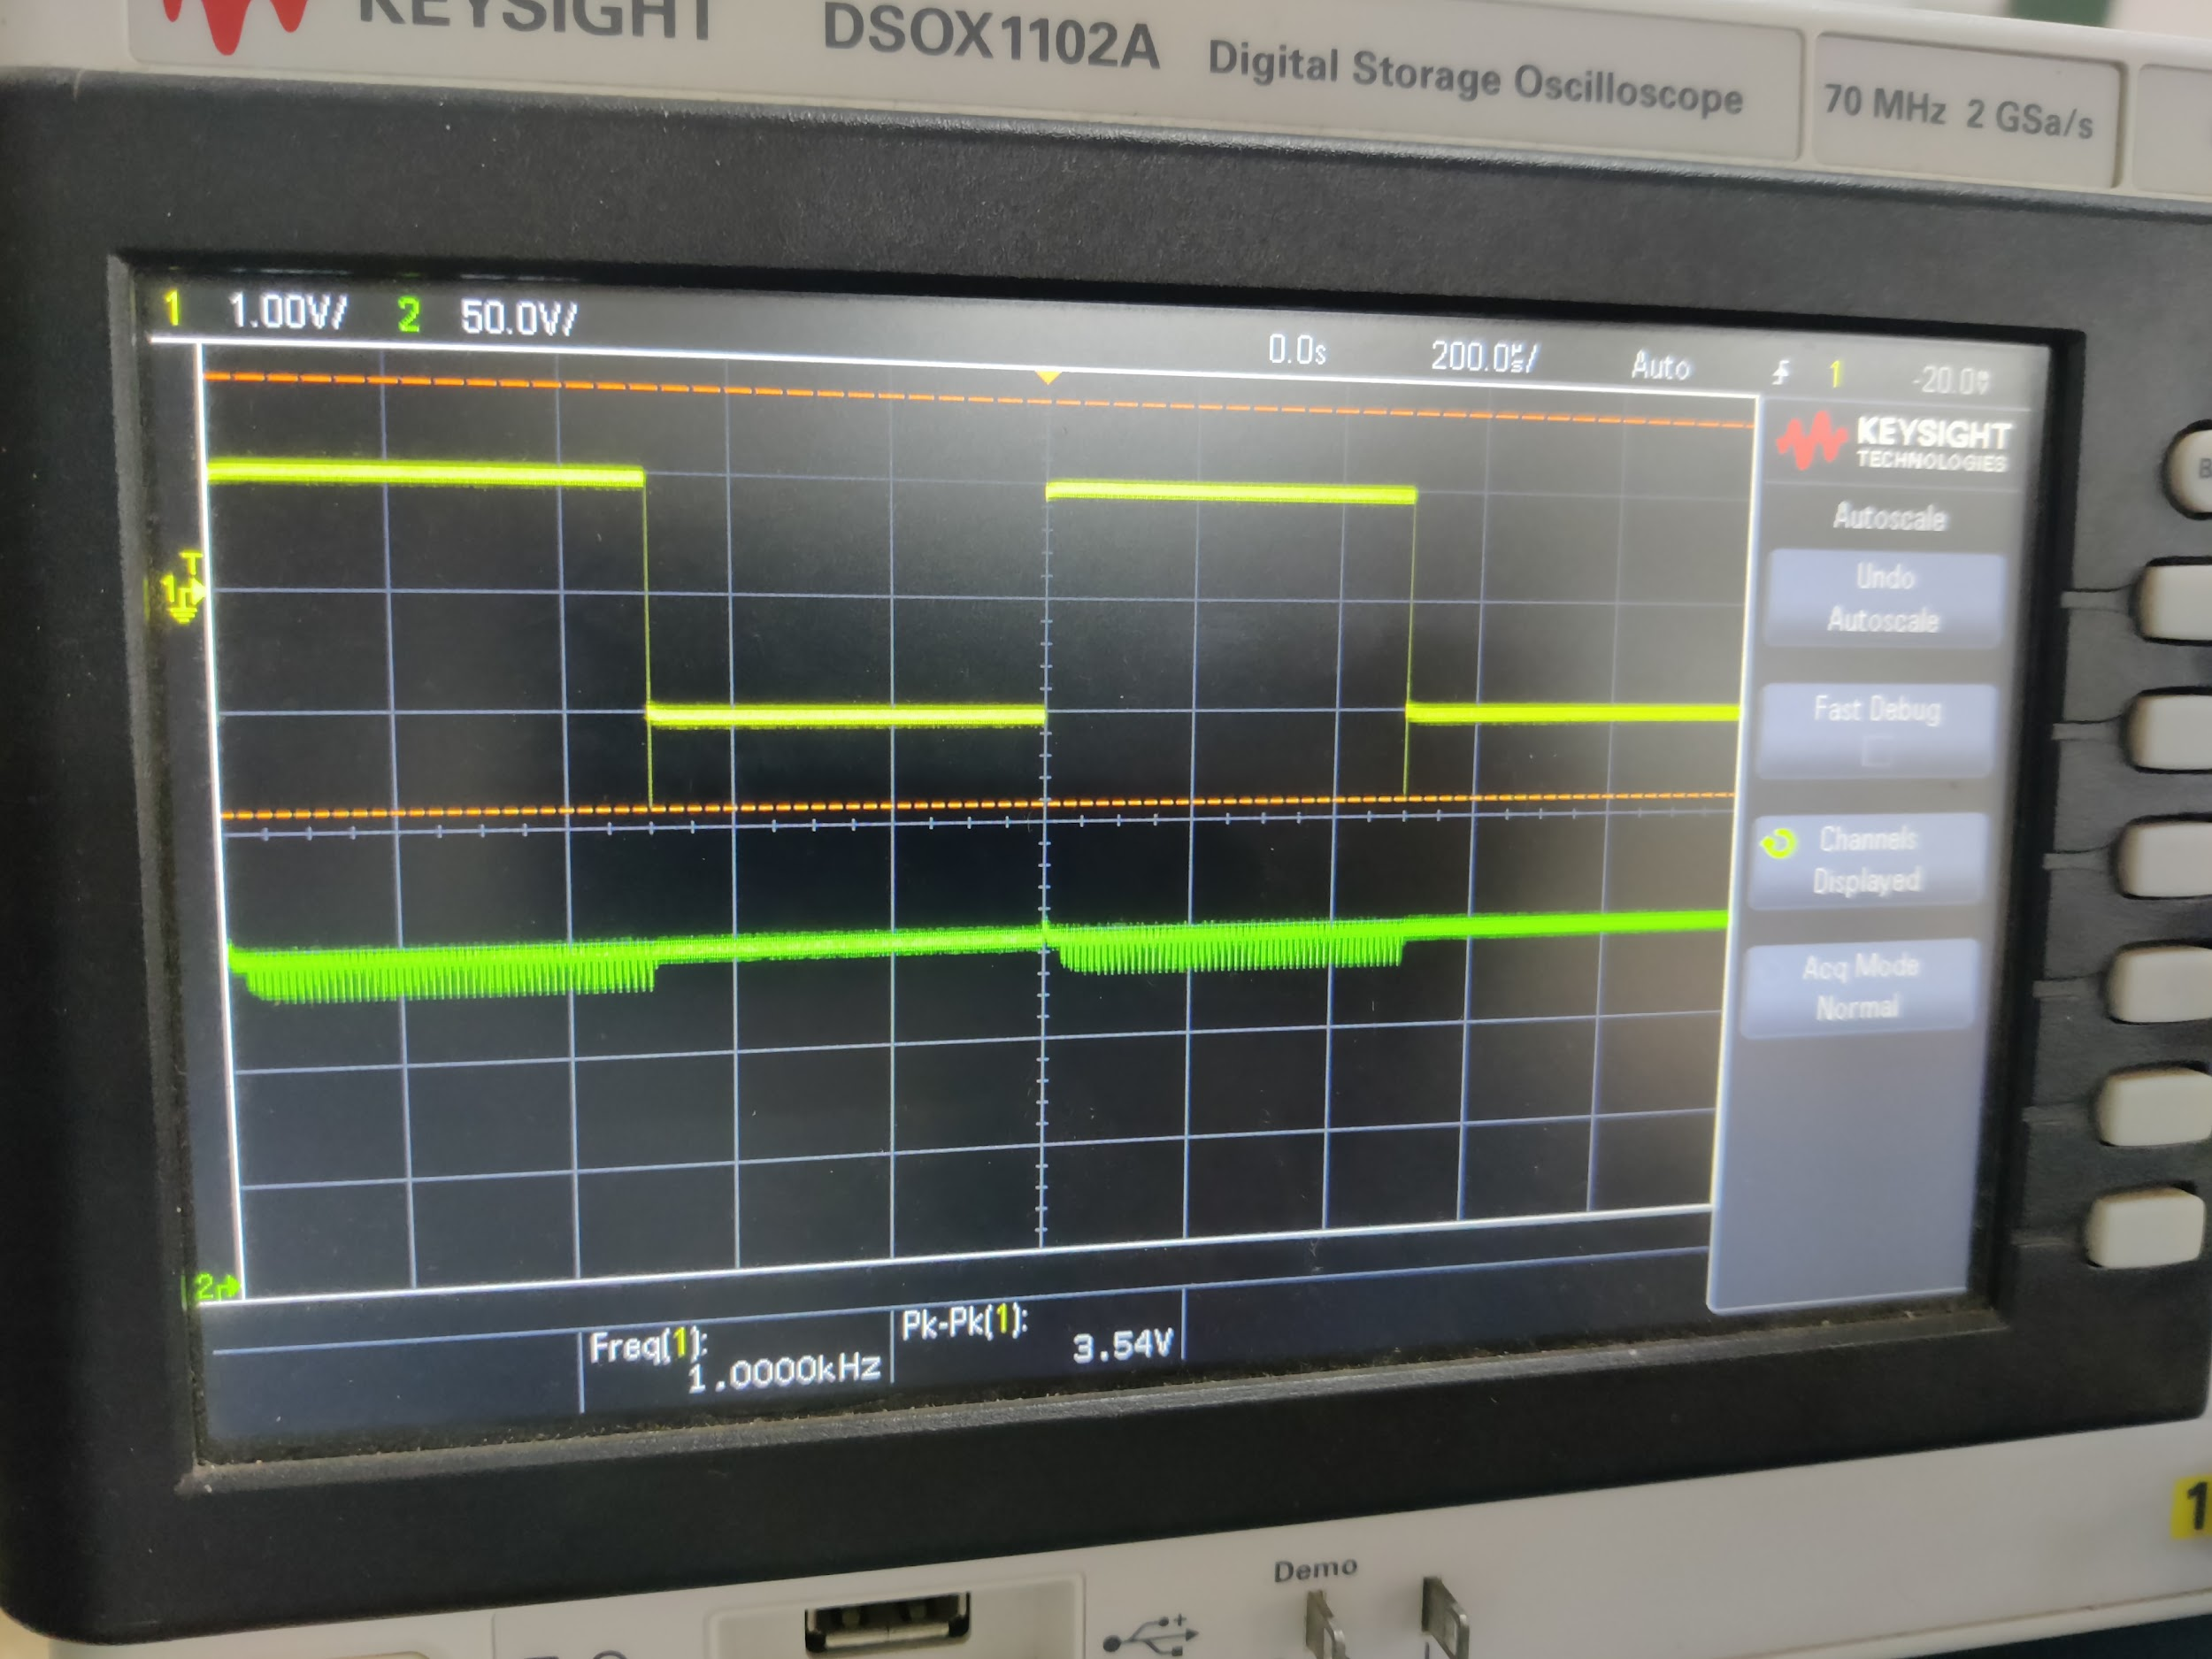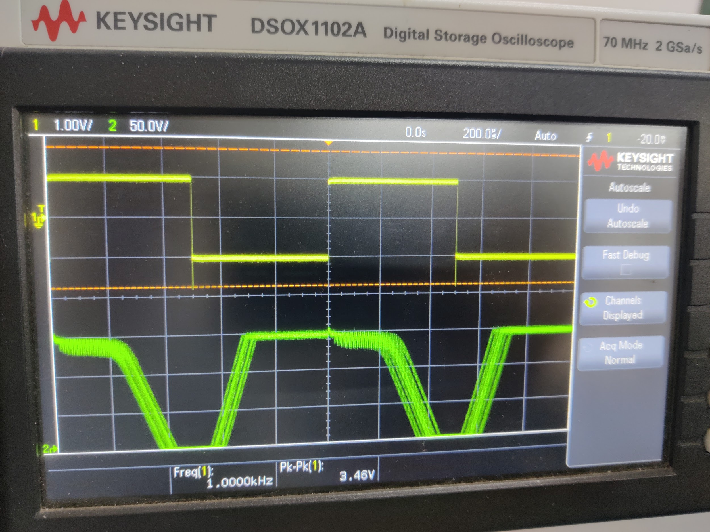

High Resistance Low Resistance

The given circuit acts as a low-pass filter. At Higher Resistances, the frequency is less, due to which almost no frequencies are allowed and the output waveform is close to zero. At lower resistances all frequencies pass through.

**Differentiator**

1.Output and Input Waveform

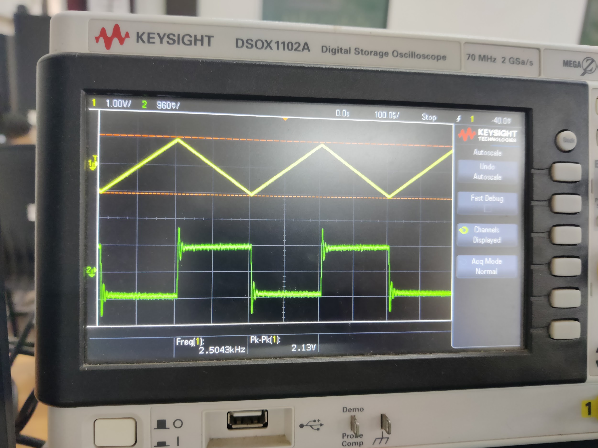

2. The resultant waveform is pretty close to our expectations. The output waveform is supposed to be a square pulse, and it is so, with some slight noise distortions.

3.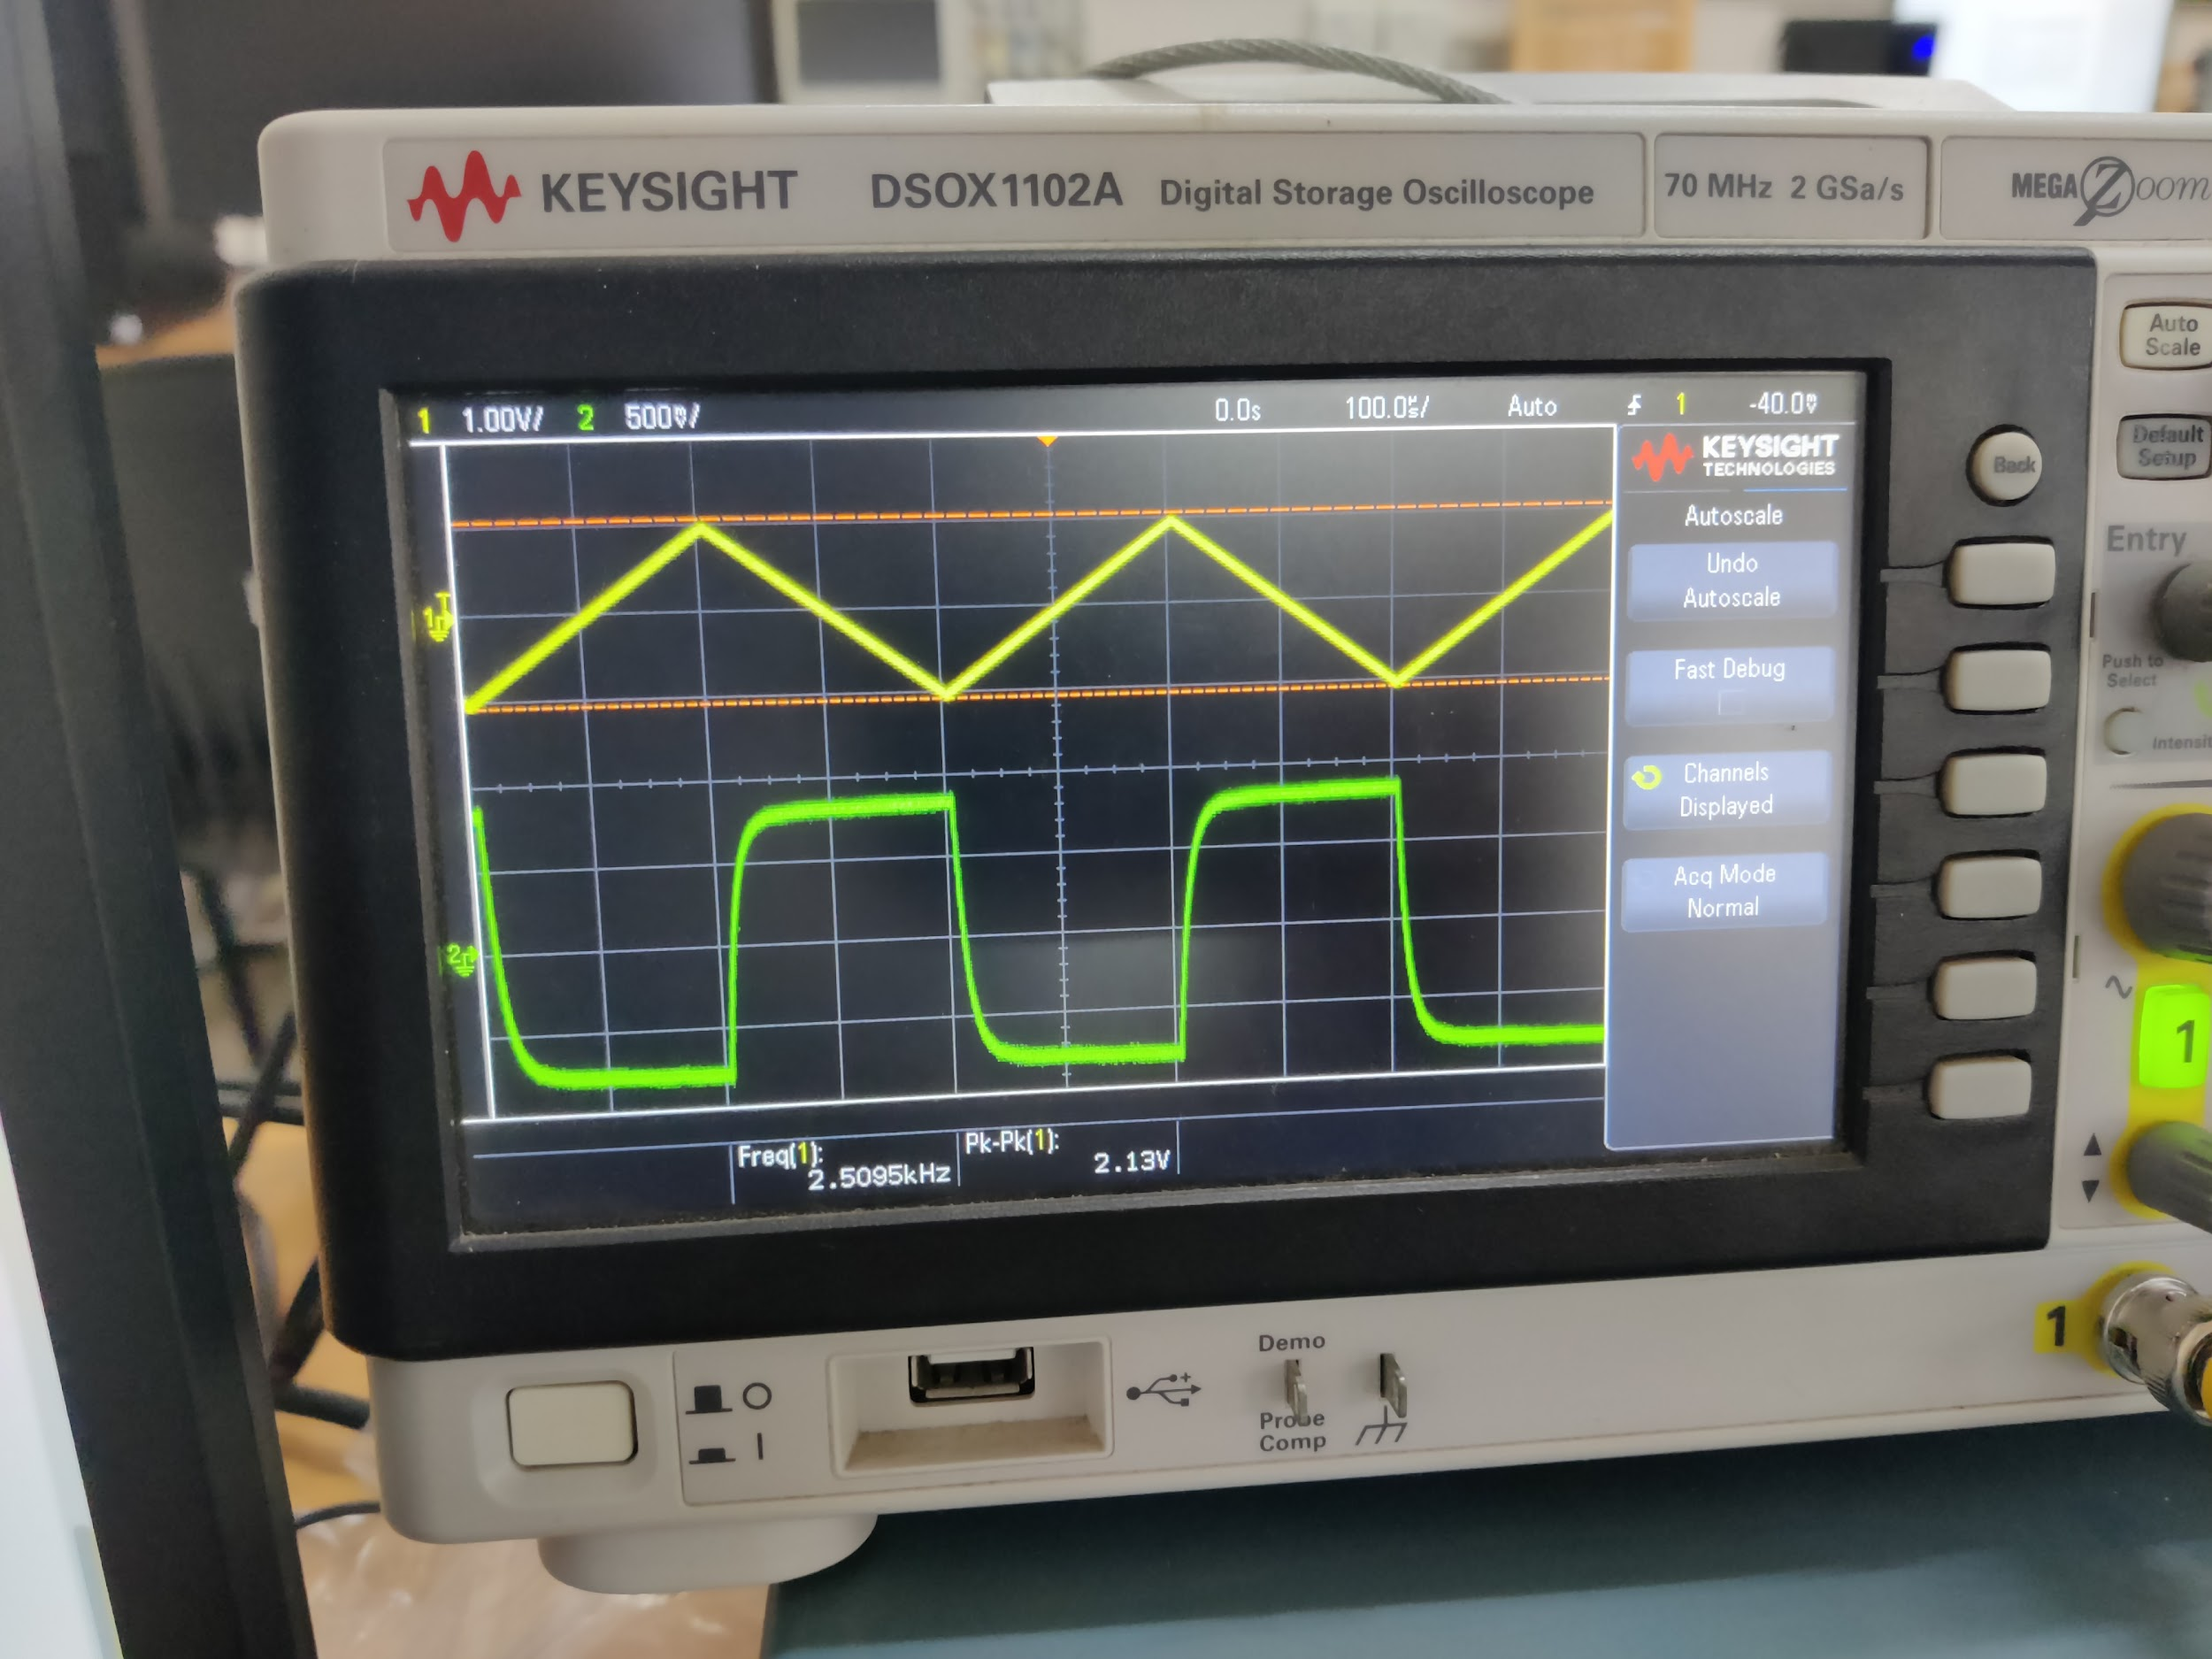

The output is almost a square wave, with some time-delay involved, given the capacitor added in the circuit.

**Results and Discussions:**

Aditya Kalyani

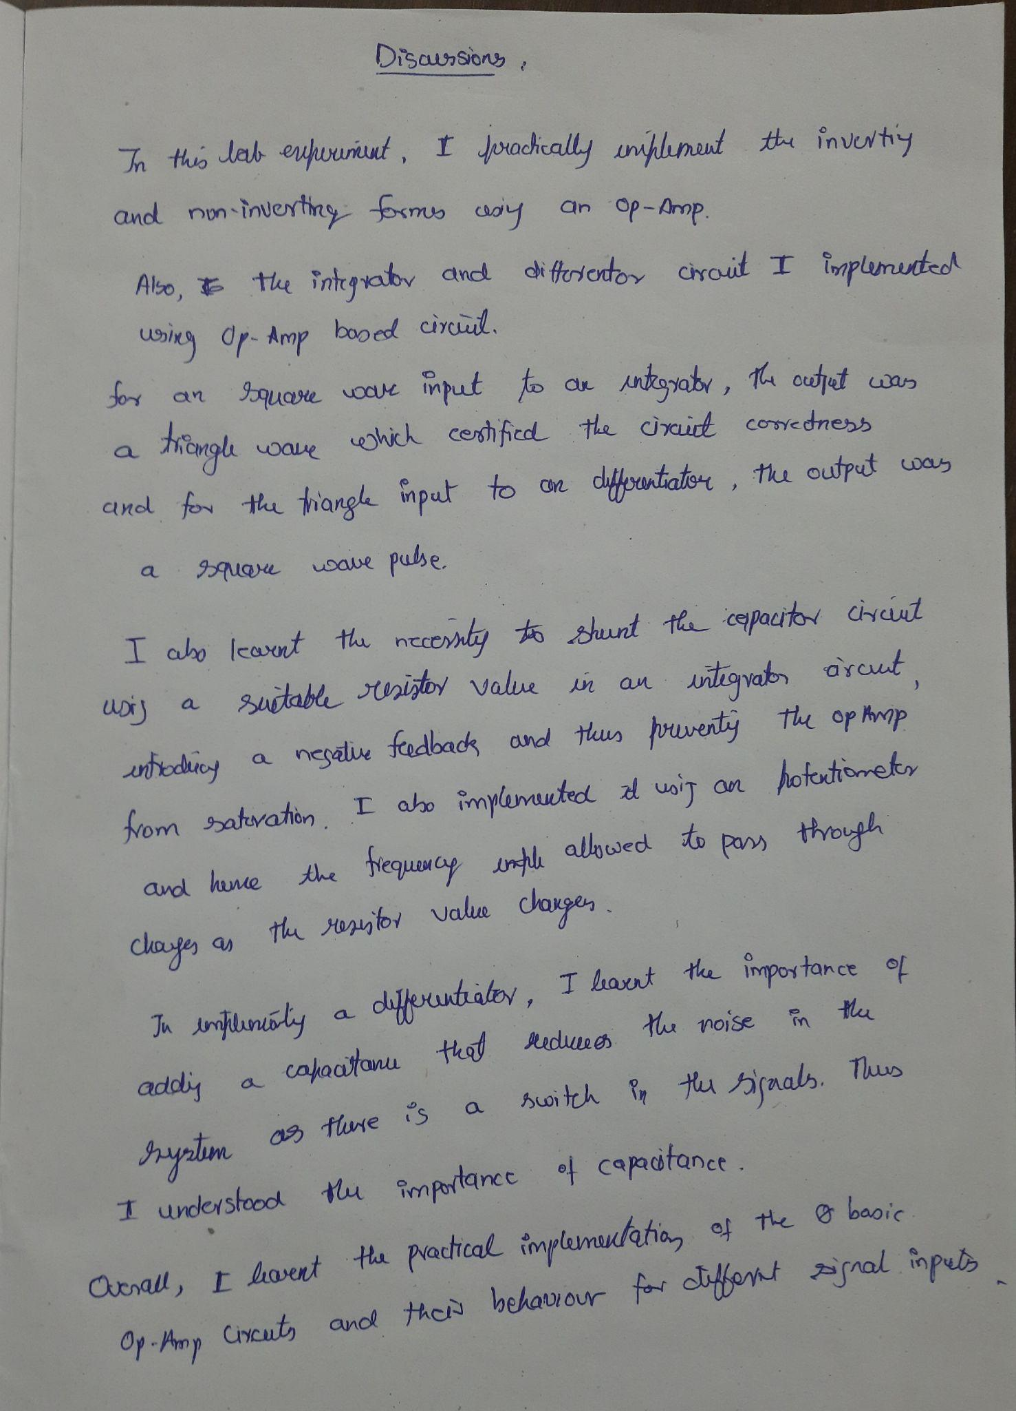

[Tanish H Talapaneni](mailto:200020050@iitdh.ac.in)

